## Finding the Area Between Two Curves

$f\left(x\right)=\sin\left(x\right)+1, g\left(x\right)=(x-1)^2$

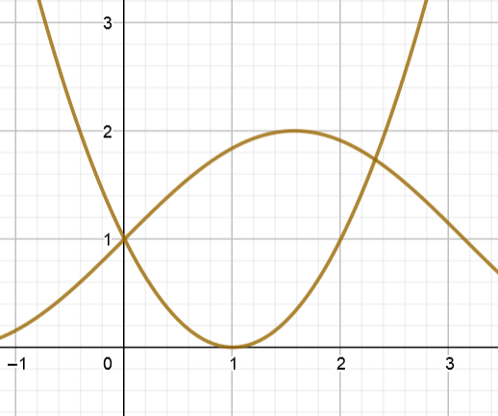The area between the two curves is the difference of their area between the curve and the y axis. If $f$ and $g$ are continuous functions on $\left[a,b\right]$, and if $f\left(x\right)≥g(x)$ for all x in $a,b$, then the area of the region bounded above by $y=f\left(x\right)$, bounded below by $y=f\left(x\right)$, on the left by $x=a,$ and on the right by $x=b$ is $\int_{a}^{b}{[f\left(x\right)-g(x)]dx}$. Remember that the function that is on top should always be first

If you are not given an interval, you have to first find the points of intersection.

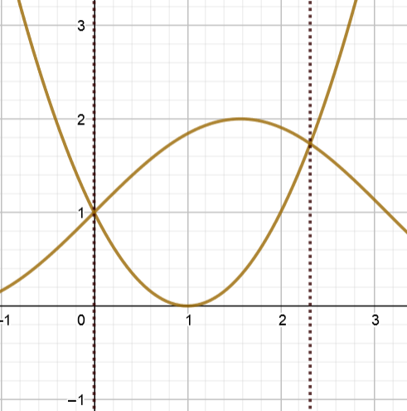

For the graph we looked at earlier, we can find the area between the two functions in between their intersection points $\left(0,1\right), and (2.317,1.734)$.

Since $g\left(x\right)=\sin\left(x\right)+1$ is the upper bound of this area it goes first in the equation

$$\int_{0}^{2.317}{\left[g(x)-f(x)\right]dx }$$

$$\int_{0}^{2.317}{\left[\left(\sin\left(x\right)+1\right)-{\left(x-1\right)}^{2}\right]dx=2.901 }$$

This is fairly simple for straightforward intervals and functions, however sometimes an area may require multiple integrals to solve.

$$f\left(x\right)=\cos\left(x\right), g\left(x\right)=sin⁡(x)$$

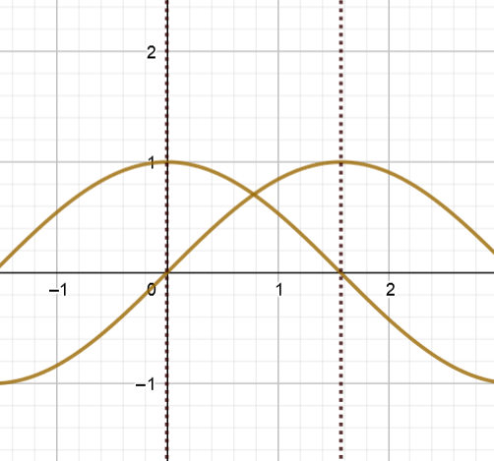

In this graph, $f\left(x\right)$ begins on top but then passes underneath $g(x)$, we must use two integrals and add them together.

$$\int_{a}^{b}{\left[f(x)-g(x)\right]dx+}\int_{b}^{c}{\left[g(x)-f(x)\right]dx}$$

$$\int_{0}^{π/4}{\left[\cos{x}-\sin{x}\right]dx+}\int_{π/4}^{π/2}{\left[\sin{x}-\cos{x}\right]dx}$$

$$\left(\sqrt{2}-1\right)+\left(\sqrt{2}-1\right)=2\sqrt{2}-2$$

There also may be cases where it would be easier to find the area with respect to $y$, such as when dealing with non-functions.

$y=x-2 and y=±\sqrt{x}$

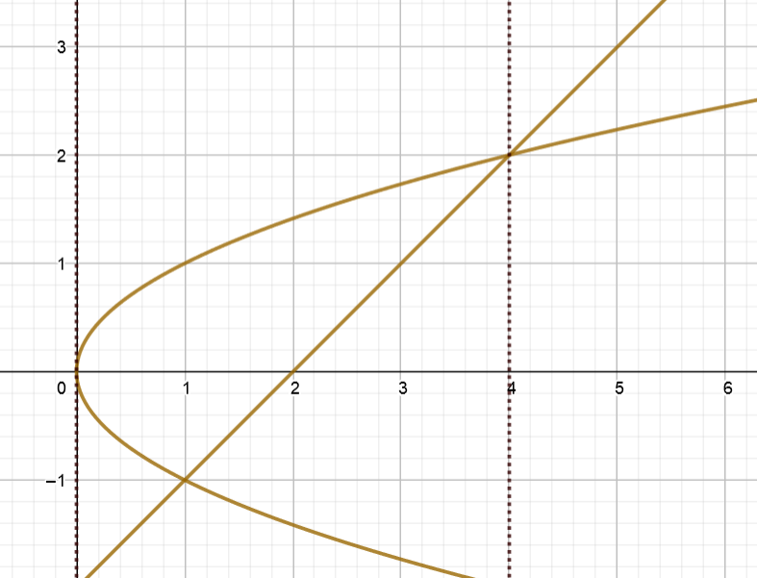

Rewrite in terms of y:

$$y=x-2→x=y+2$$

$$y=±\sqrt{x}→x=y^{2}$$

Interval: $\left[-1,2\right]$ (y values)

The equation on the right becomes the top equation $\left(y=x-2\right)$

$$\int_{-1}^{2}{\left[(y+2)-(y^{2})\right]dx=\frac{9}{2} }$$

## Formulas for Volume of a Solid of Revolution

Disk method:

$$V=π\int_{a}^{b}{{\left[R(x)\right]}^{2}dx } and V=π\int_{c}^{d}{{\left[R(y)\right]}^{2}dy}$$

A solid of revolution is formed when a region or area on a 2d plane is revolved around an axis of revolution. A cylinder for example is a solid of revolution formed when a rectangle is revolved around its axis of revolution, and the volume becomes $πR^{2}∆x$. When finding the volume of more complex solids of revolution, you may think to approximate using several of these cylinders or disks leading to the formula $V≈π\sum_{i=1}^{n}{{\left(R\left(x_{i}\right)\right)}^{2}∆x}$. Using the limiting process to improve this approximation by making the number of disks approach infinity leads to the integration formula $V=π\int_{a}^{b}{{\left[R(x)\right]}^{2}dx }$ for a horizontal axis of revolution or $V=π\int_{a}^{b}{{\left[R(y)\right]}^{2}dy}$ for a vertical axis of revolution

$$∆x$$

$$R$$

Washer Method:

$$V= π\int_{a}^{b}{\left({\left[R\left(x\right)\right]}^{2}-{\left[r\left(x\right)\right]}^{2}\right)dx}$$

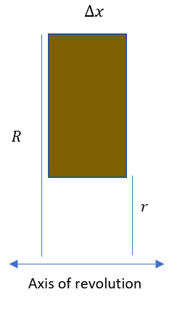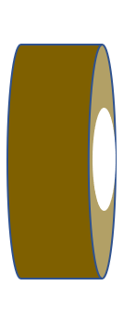The washer method is an extension of the disk method. The volume of this washer is $V= π\left(R^{2}-r^{2}\right)w$. To apply to any solid of revolution we can $V= π\int_{a}^{b}{\left({\left[R\left(x\right)\right]}^{2}-{\left[r\left(x\right)\right]}^{2}\right)dx}$. The volume caused by the inner radius r is subtracted from the volume created by the larger radius R.

**EXAMPLE 10:**

Shell Method:

$$V= 2πphw$$

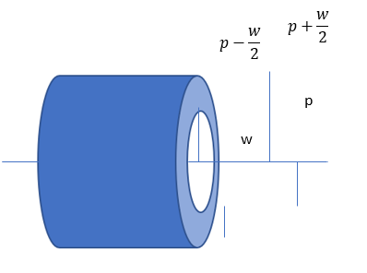The shell method takes a different approach then the washer method for the same solids of revolutions. Similarly we can understand the formula by looking at this basic cylinder with a hole. $π{\left(p+\frac{w}{2}\right)}^{2}h-π{\left(p-\frac{w}{2}\right)}^{2}h→2πphw$. This formula came from the volume of the cylinder – the volume of the hole. $2πphw$ is representitive of $2π(average radius(height)(thickness))$

**EXAMPLE 11:**

Shell vs. Washer methods.

## Formulas for Volume of a Solid of Revolution

Perpendicular to the x-axis $V= \int_{a}^{b}{A\left(x\right)dx}$

Perpendicular to the y-axis $V= \int_{c}^{d}{A\left(y\right)dy}$

**EXAMPLE 12:**

## Arc Length

Let the function $y=f(x)$ represent a smooth curve on the interval $\left[a,b\right]$. The arc length of $f$ between a and b is $s=\int_{a}^{b}{\sqrt{1+{\left[f^{'}\left(x\right)\right]}^{2}}dx}$. Similarly, for a smooth curve $x=g(y)$, the arc length of g between c and d is $s=\int_{c}^{d}{\sqrt{1+{\left[g'\left(y\right)\right]}^{2}}dy}$

## Surface Area

Let $y=f(x)$ have a continuous derivative on the interval $\left[a,b\right]$. The area S of the surface of revolution formed by revolving the graph of $f$ about a horizontal or vertical axis is $S=2π\int_{a}^{b}{r(x)\sqrt{1+{\left[f^{'}\left(x\right)\right]}^{2}}dx}$ where $r(x)$ is the distance between the graph of $f$ and the axis of revolution. If $x=g\left(y\right)$ on the interval $\left[c,d\right],$ then the surface area is $S=2π\int_{a}^{b}{r(y)\sqrt{1+{\left[g^{'}\left(y\right)\right]}^{2}}dy}$ where $r(y)$ is the distance between the graph of $g$ and the axis of revolution.